Mechanical Overview

Year: 2023 Semester: Spring Team: 18 Project: RDNT

Creation Date: 11 February 2023 Last Modified: 11 February 2023

Author: Graeme Usman Email: gusman@purdue.edu

Assignment Evaluation:

| **Item** | **Score (0-5)** | **Weight** | **Points** | **Notes** |
| --- | --- | --- | --- | --- |
| **Assignment-Specific Items** | | | | |
| **Commercial Packaging Analysis 1** |  | x2 |  |  |
| **Commercial Packaging Analysis 2** |  | x2 |  |  |
| **CAD Model Illustrations** |  | x4 |  |  |
| **Project Packaging Specifications** |  | x2 |  |  |
| **PCB Footprint Layout** |  | x2 |  |  |
| **Writing-Specific Items** | | | | |
| **Spelling and Grammar** |  | x2 |  |  |
| **Formatting and Citations** |  | x1 |  |  |
| **Figures and Graphs** |  | x2 |  |  |
| **Technical Writing Style** |  | x3 |  |  |
| **Total Score** |  | | |  |

5: Excellent 4: Good 3: Acceptable 2: Poor 1: Very Poor 0: Not attempted

Comments:

*Comments from the grader will be inserted here.*

1. Commercial Product Packaging
   1. Product #1: IVUDA Audio Visualizer, 14-Segment Music Spectrum Analyzer Kit/Led Acrylic Level Display for Music Lover and Electronic Lover [2]

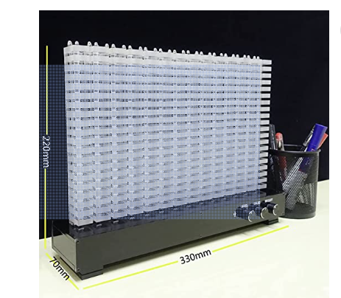

This design uses an acrylic matrix with LED bulbs placed inside. This allows the “pixelation” of the led bulbs to be hidden. We will use our acrylic sheets to achieve a very similar effect. Their device uses the red/white speaker cables and our device will use AUX-in, microphone, and bluetooth connections. Therefore our device will be easier to interface with. Our display is much larger and will allow for much more customization through our Android app. Particularly, we will allow for multiple color ranges to be selected by the user. The product has 3 knobs for controlling the audio input. This is a nice design and we will consider implementing knobs for external controls.

* 1. Product #2: Led Music Spectrum Display Clock, Audio Visualizer,Digital Visualizer Clock with Temperature Display, 7 Spectrum Modes Switch, Music Visualizations Device for Party, Bedroom, Camping [1]

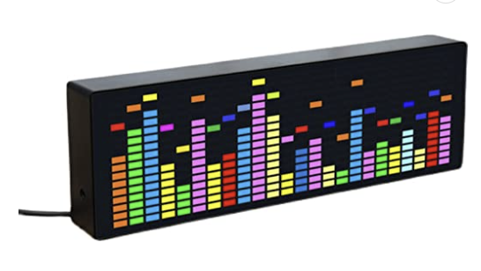

This product features a LED lamp bead grid display. It also features a clock mode and temperature display. This is a very interesting use of space as it can replace the use of a clock in the customer’s home. Our device will feature more customization as the user can customize color ranges beyond this product’s 7 built in modes. Our device will be substantially larger and likely not be placed onto a table/desk like this product. This product has alarms built into its clock functions. We will consider the multiple uses of LED strips beyond just displaying colors.

2.0 Project Packaging Description

Our project will consist of two objects. One will be the circuit housing, which will be a project box that we will drill holes into. These holes will allow us to attach audio I/O, external controls, power from a wall adapter, and the male header for our LED strips. The male header will connect to our second object, the LED fixture. This LED fixture will be a large wooden display case with 6 acrylic hollow sections that the LEDs will be located in. We will use 6 acrylic sections to represent the 6 main bands of audible frequencies. The wooden case simply houses the many acrylic sections and provides space to hide the wires. If wood becomes hard to work with, we will consider other options for materials.

3.0 Sources Cited

[1] Bogaert, R. (1980). *Audio Spectrum Analyzer*. Amazon. Retrieved February 11, 2023, from https://www.amazon.com/Audio-Spectrum-Analyzer/s?k=Audio%2BSpectrum%2BAnalyzer

[2]*Amazon.com - IVUDA Audio Visualizer, 14-Segment Music Spectrum Analyzer ...* (n.d.). Retrieved February 12, 2023, from https://www.amazon.com/IVUDA-Visualizer-14-Segment-Spectrum-Electronic/dp/B0BG92X1Q7

Appendix 1: CAD Model Illustrations

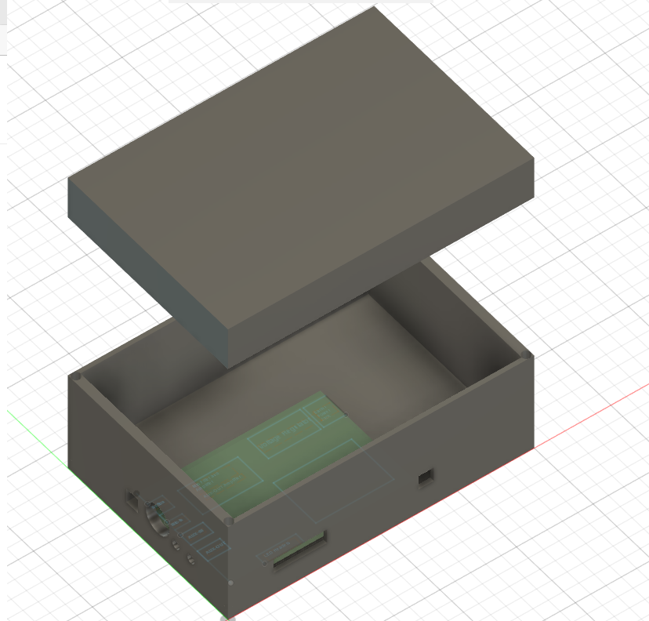

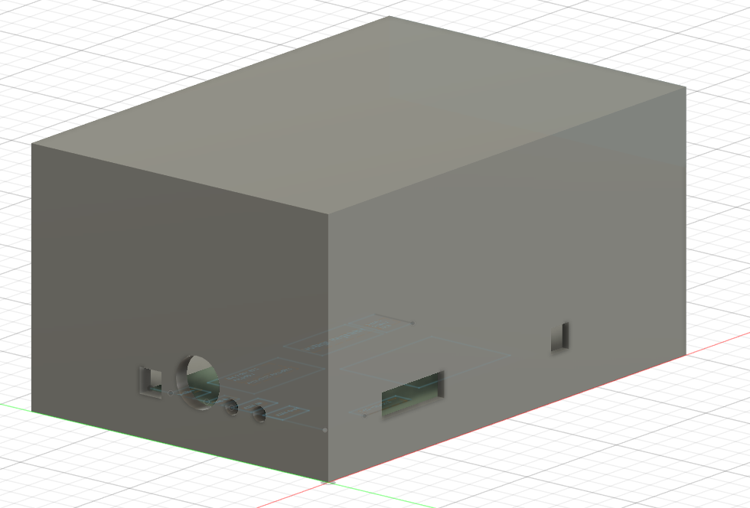

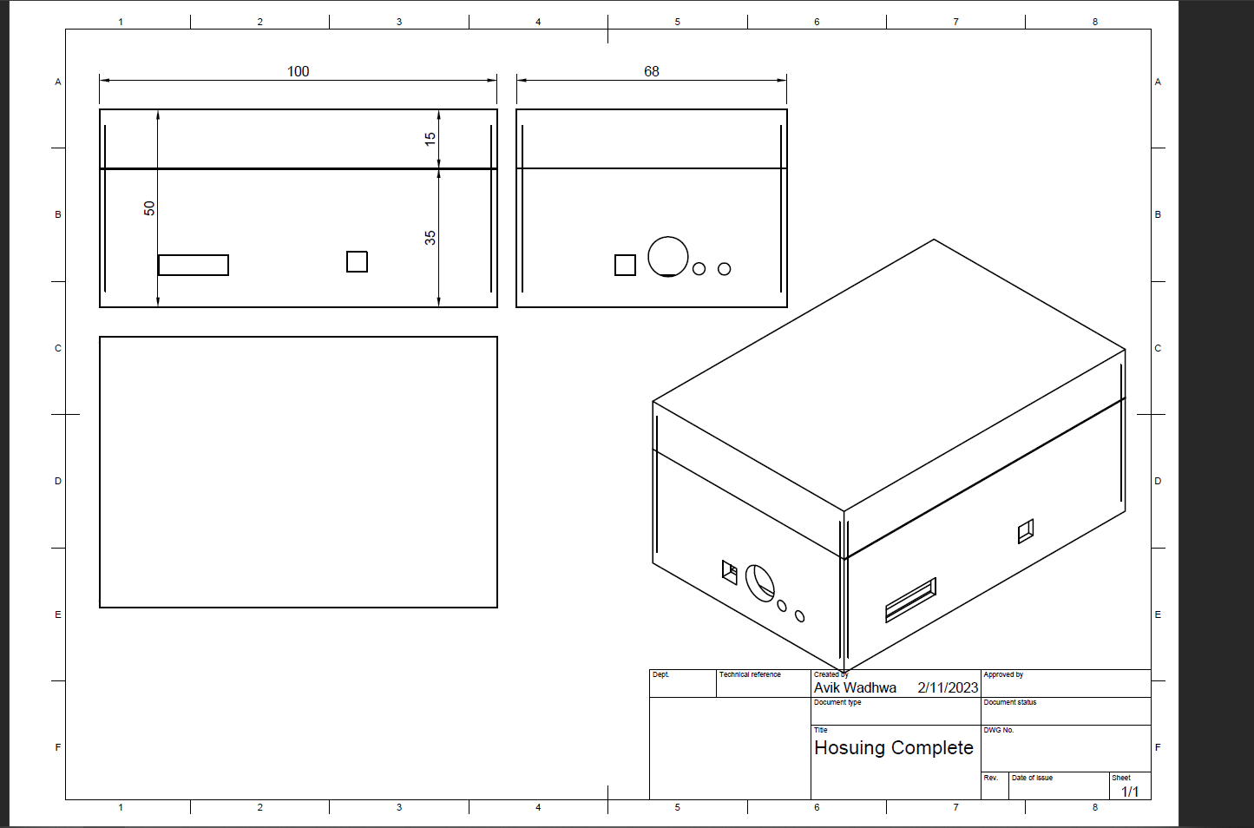

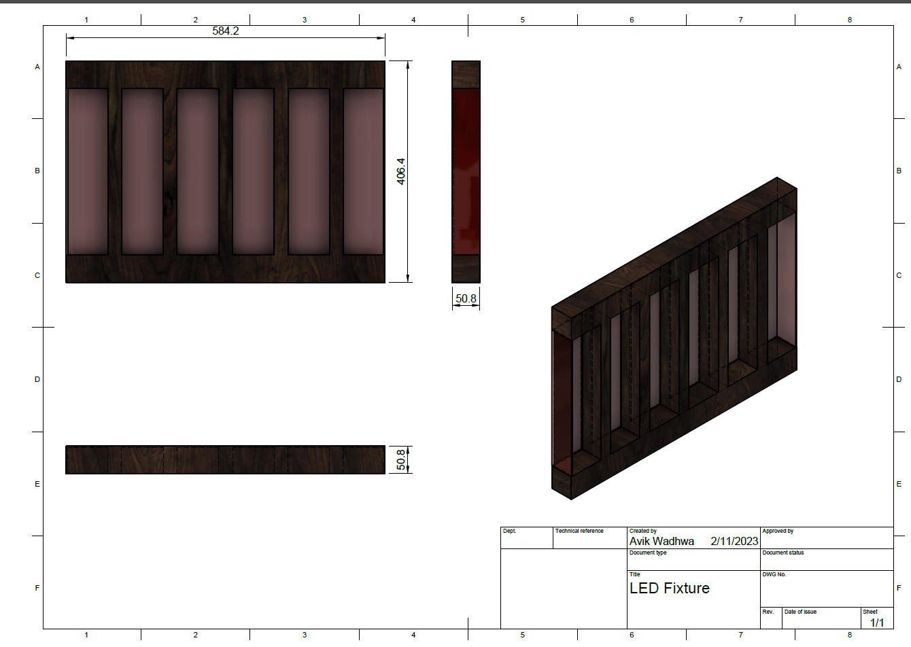

Note: units are mm.

Appendix 2: Project Packaging Specifications

| Material | Tools Required | Weight | Unit Cost |
| --- | --- | --- | --- |
| Frosted Acrylic | Laser Cutter | 3.31 lb. | $ 32.28 |
| Walnut Planks | Hand Saw, Clamps, Wood Glue, Hand Sander | 40-60lb. | $ 32.00 |
| Wood Screws | Hand Drill | 1 lb. | $ 10.99 |
| Wood Glue | Towels, Clamps | 8.96 oz. | $3.29 |
| Dark Wood Stain | Towels, Brushes | 1 quart | $ 12.98 |
| Wood Varnish | Towels, Brushes | 1 quart | $ 23.98 |
| Project Box | Hand Drill | 2 lb. | $ 9.99 |

Appendix 3: PCB Footprint Layout

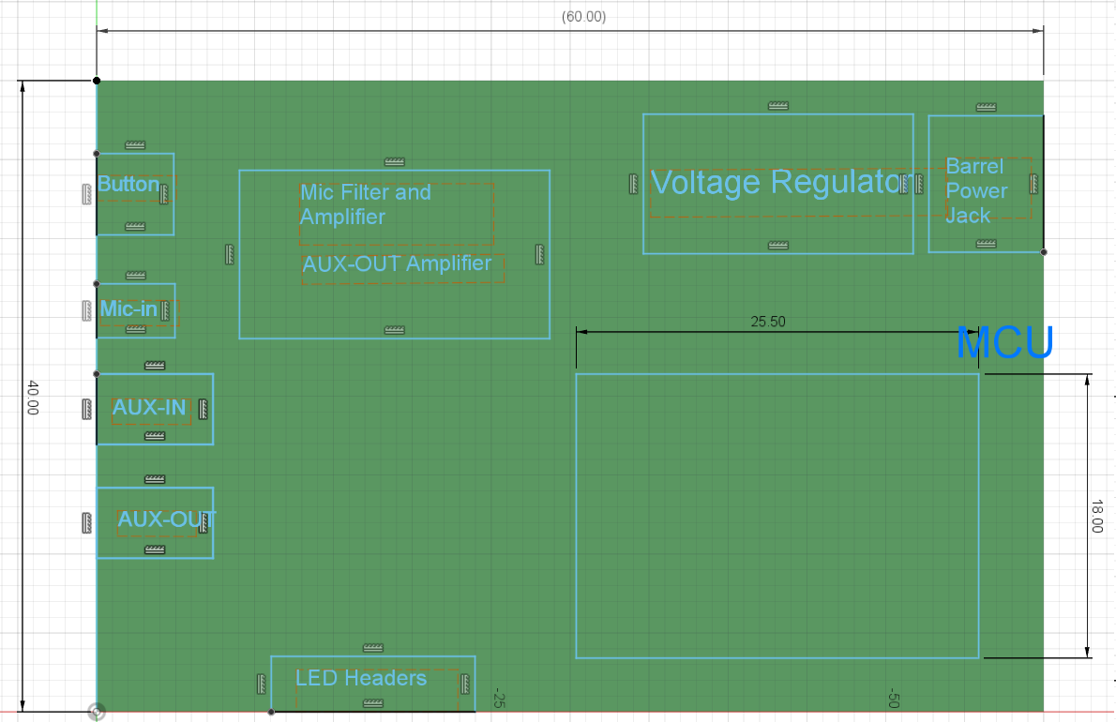

We have the left face categorized by power, operational amplifier, and external peripherals (audio I/O and LEDs). The spacing accounts for decoupling capacitors, amplifier circuitry, and varying trace widths. It is vital to note that LED headers may require larger trace widths, which may likely run through the bottom layer. To account for connection with the voltage regulator, the position of the voltage regulator and MCU may be switched when we move on to adding traces if the connection is causing noise concerns due to the higher expected current in traces to the LED headers.